CL 2006 OPERATING SYSTEM

BS Software Engineering

Course Instructors: Syed Daniyal Hussain Shah, Hifza Umar



Lab 8: Signals

Signals:
Signals are a form of limited inter-process communication (IPC). Signals are used to notify a process that an event has occurred. Each signal has a number and a default action associated with it, such as terminating the process or ignoring the signal.

How Signal Works:
- A signal can be sent to a process or a group of processes.
• Signals can be generated by:
  - The kernel (e.g., when a segmentation fault occurs).
  - A user (e.g., via the kill command).
  - Another process (using kill system call).
- The process receiving the signal can:
- Take the default action.
- Ignore the signal.
- Handle the signal using a signal handler.

Types of Signals:
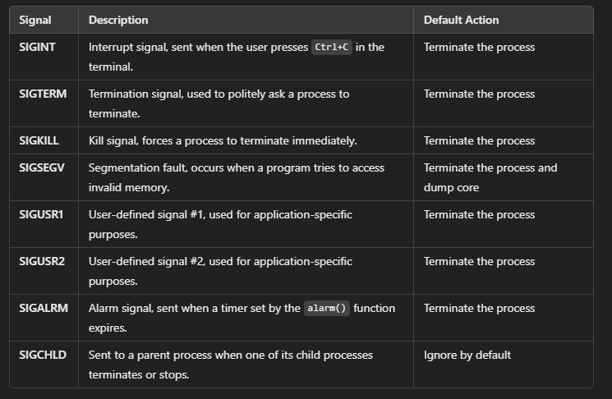

SIGINT (Signal Interrupt):
SIGINT is sent when you press Ctrl+C in the terminal.

Example:
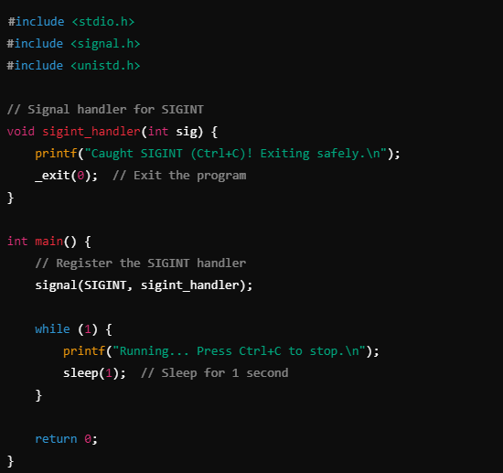

The program registers a handler for SIGINT. When Ctrl+C is pressed, it prints a message and exits.
Without this handler, Ctrl+C would terminate the program immediately.

Output:
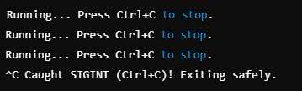

SIGTERM (Termination Signal):
SIGTERM is a signal that can be sent to a process to request its termination. It can be caught, blocked, or ignored.

Example:
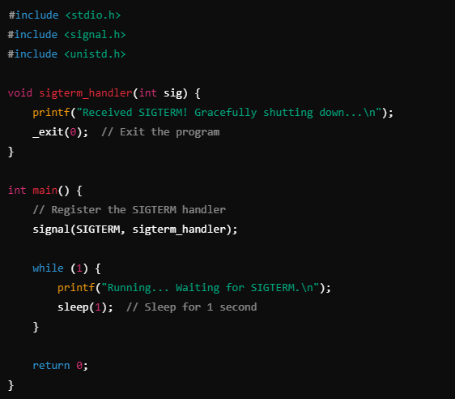

How to Send SIGTERM:
- Run the program in one terminal.
- In another terminal, find the process ID (PID) using ps.
- Use the kill command: kill -SIGTERM <PID>.

Output:
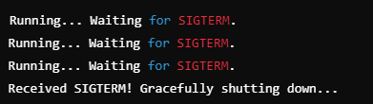

SIGKILL (Kill Signal):
SIGKILL forces a process to terminate immediately. This signal cannot be caught, blocked, or ignored. It is used when you want to forcefully kill a process.
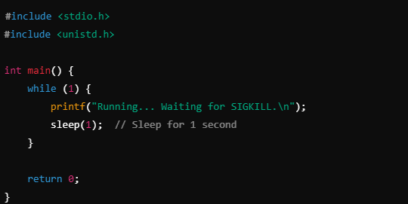

How to Send SIGKILL:
- Run the program in one terminal.
- In another terminal, use the kill command: kill -SIGKILL <PID>.

Example:
SIGALRM is sent when a timer set by the alarm function expires.
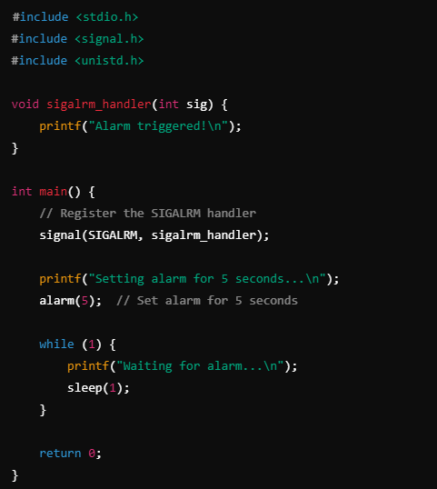
The program sets an alarm for 5 seconds using alarm(5).
After 5 seconds, SIGALRM is sent to the process, and the signal handler is triggered.

Output:
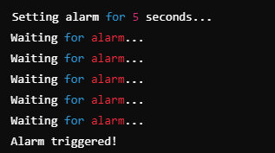

SIGSEGV (Segmentation Fault):
SIGSEGV is generated when a program attempts to access an invalid memory location.

Example:
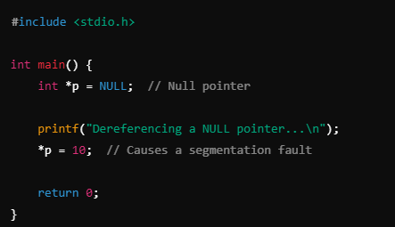
This program tries to dereference a NULL pointer, causing a segmentation fault, which generates a SIGSEGV.

Output:
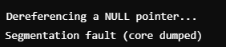

SIGUSR1 and SIGUSR2 (User-Defined Signals):
These are user-defined signals for custom inter-process communication.
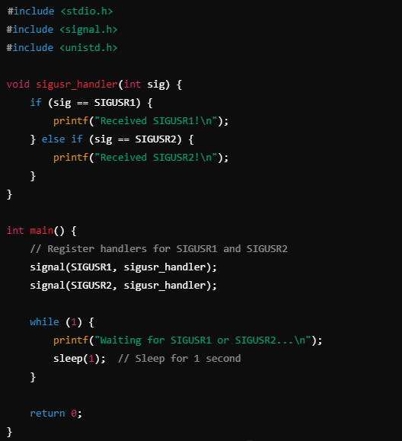
Run the program in one terminal.
In another terminal, send SIGUSR1 or SIGUSR2 using:
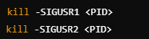

Output:
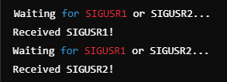

SIGCHLD (Child Termination Signal):
SIGCHLD is sent to a parent process when one of its child processes terminates or stops. The parent process can catch this signal to handle the termination or stopping of the child process (e.g., using wait to clean up).

Example:

#include <stdio.h>
#include <stdlib.h>
#include <unistd.h>
#include <signal.h>
#include <sys/wait.h>

// Signal handler for SIGCHLD
void sigchld_handler(int sig) {
int status;
pid_t pid;

// Wait for the child process to finish
pid = wait(&status);
if (pid > 0) {
printf("Child process %d terminated with status %d\n", pid, WEXITSTATUS(status));
}
}

int main() {
// Register the SIGCHLD handler
signal(SIGCHLD, sigchld_handler);

pid_t pid = fork();

if (pid == 0) {
// This is the child process
printf("Child process (PID: %d) is running...\n", getpid());
sleep(2); // Simulate work in the child process
printf("Child process (PID: %d) is exiting...\n", getpid());
exit(0); // Child process exits
} else if (pid > 0) {
// This is the parent process
printf("Parent process (PID: %d) is waiting for the child...\n", getpid());
while (1) {
// Parent keeps running, waiting for SIGCHLD
sleep(1);
}
} else {
// Fork failed
perror("fork");
return 1;
}

return 0;
}

The parent process forks a child process.
The parent registers a SIGCHLD signal handler to be notified when the child process terminates.
The child process runs for 2 seconds and then terminates.
The parent catches SIGCHLD when the child exits, prints the child's exit status, and continues running.

Output:
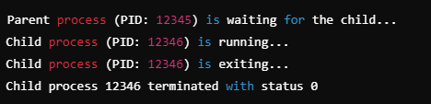

When the child process terminates, the SIGCHLD signal is sent to the parent.
The parent handles SIGCHLD, waits for the child process to terminate using wait(), and retrieves the child's exit status.
By default, SIGCHLD is ignored if the parent doesn't handle it. In this case, the child process would remain a zombie process (i.e., a process that has terminated but hasn't been cleaned up by the parent).
Using wait or waitpid in the SIGCHLD handler ensures that the child process is properly cleaned up.

Pause():
The pause() function in Linux is used to suspend a process (put it to sleep) until it receives a signal. When a signal arrives, the process will wake up and continue executing from where it left off. If there is no signal handler, the default action for the signal will occur, such as terminating the process.
It is often used to ensure that the process waits for a signal and doesn't terminate or continue running before the signal is received. It effectively makes the process “wait” or block until the signal arrives.
Without pause(), the program might terminate or proceed to the next steps immediately, without waiting for a signal, especially if the program is meant to handle signals.

Raise():
Raise() system call is used to send signals from within the same process.

Example:
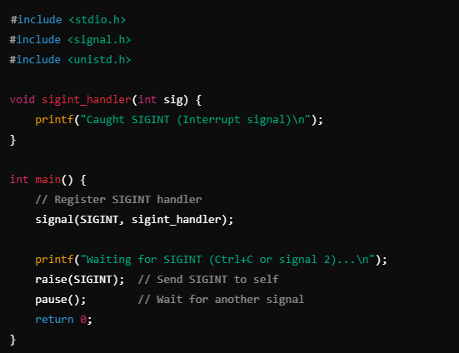

Output:
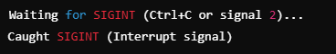

Kill():
You can use the kill() system call to send signals from one process to another. To send a signal, you need the process ID (PID) of the target process. Here is how you can send signals from one process to another. Also in the example below we are using signal number instead of signal name.

Sender Program (Sends a signal to another program):
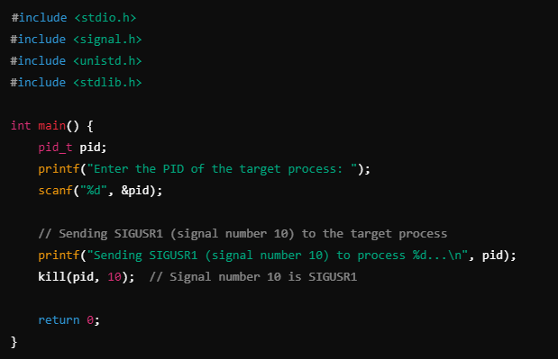

Receiver Program (Receives the signal):
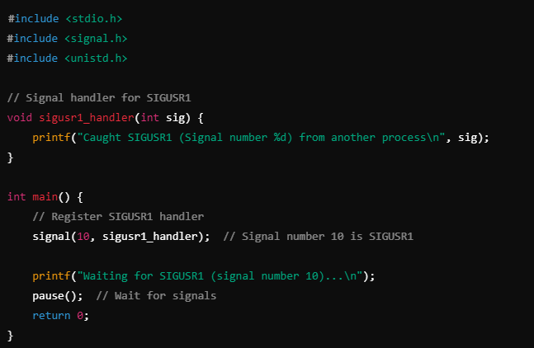
Compile and run the receiver program in one terminal.
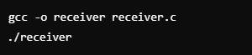
It will print something like this and wait for the signal:

In another terminal, find the PID of the receiver program

Note the PID of the running receiver program.
Compile and run the sender program in the other terminal, and provide the PID of the receiver process.
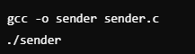
Enter the PID of the receiver process when prompted.
After entering the PID, the receiver program will display:

Tasks:

- Write a C program that installs signal handlers for SIGINT, SIGTERM, and SIGALRM. When each signal is received, the program should print a custom message indicating which signal was received. Use pause() to keep the program running and waiting for signals.
- Write two programs:
Sender Program: This program should take a process ID (PID) as an argument and send a signal (using kill()) to the specified process. The signal should be specified either by name or by its signal number.
Receiver Program: This program should install a handler for SIGUSR1 and SIGUSR2. When one of these signals is received, the program should print a message.
- Write a parent-child program where the parent process forks a child process. The parent should install a handler for SIGCHLD to be notified when the child process terminates. Once the child finishes, the parent should print a message indicating that the child process has completed.

Task Submission Guidelines:
- Make a document and paste all tasks solution there (Not screenshot) and save it as pdf.
- Along with each task solution, also upload the screenshot of the output.
- Include your name and roll no. at the front page.
- Please submit your file in this format (Roll_number-name) i.e (24I-1234-Ali.pdf).
- Files other than pdf will not be accepted and will be marked as 0.

